Tac-Tile Warfare

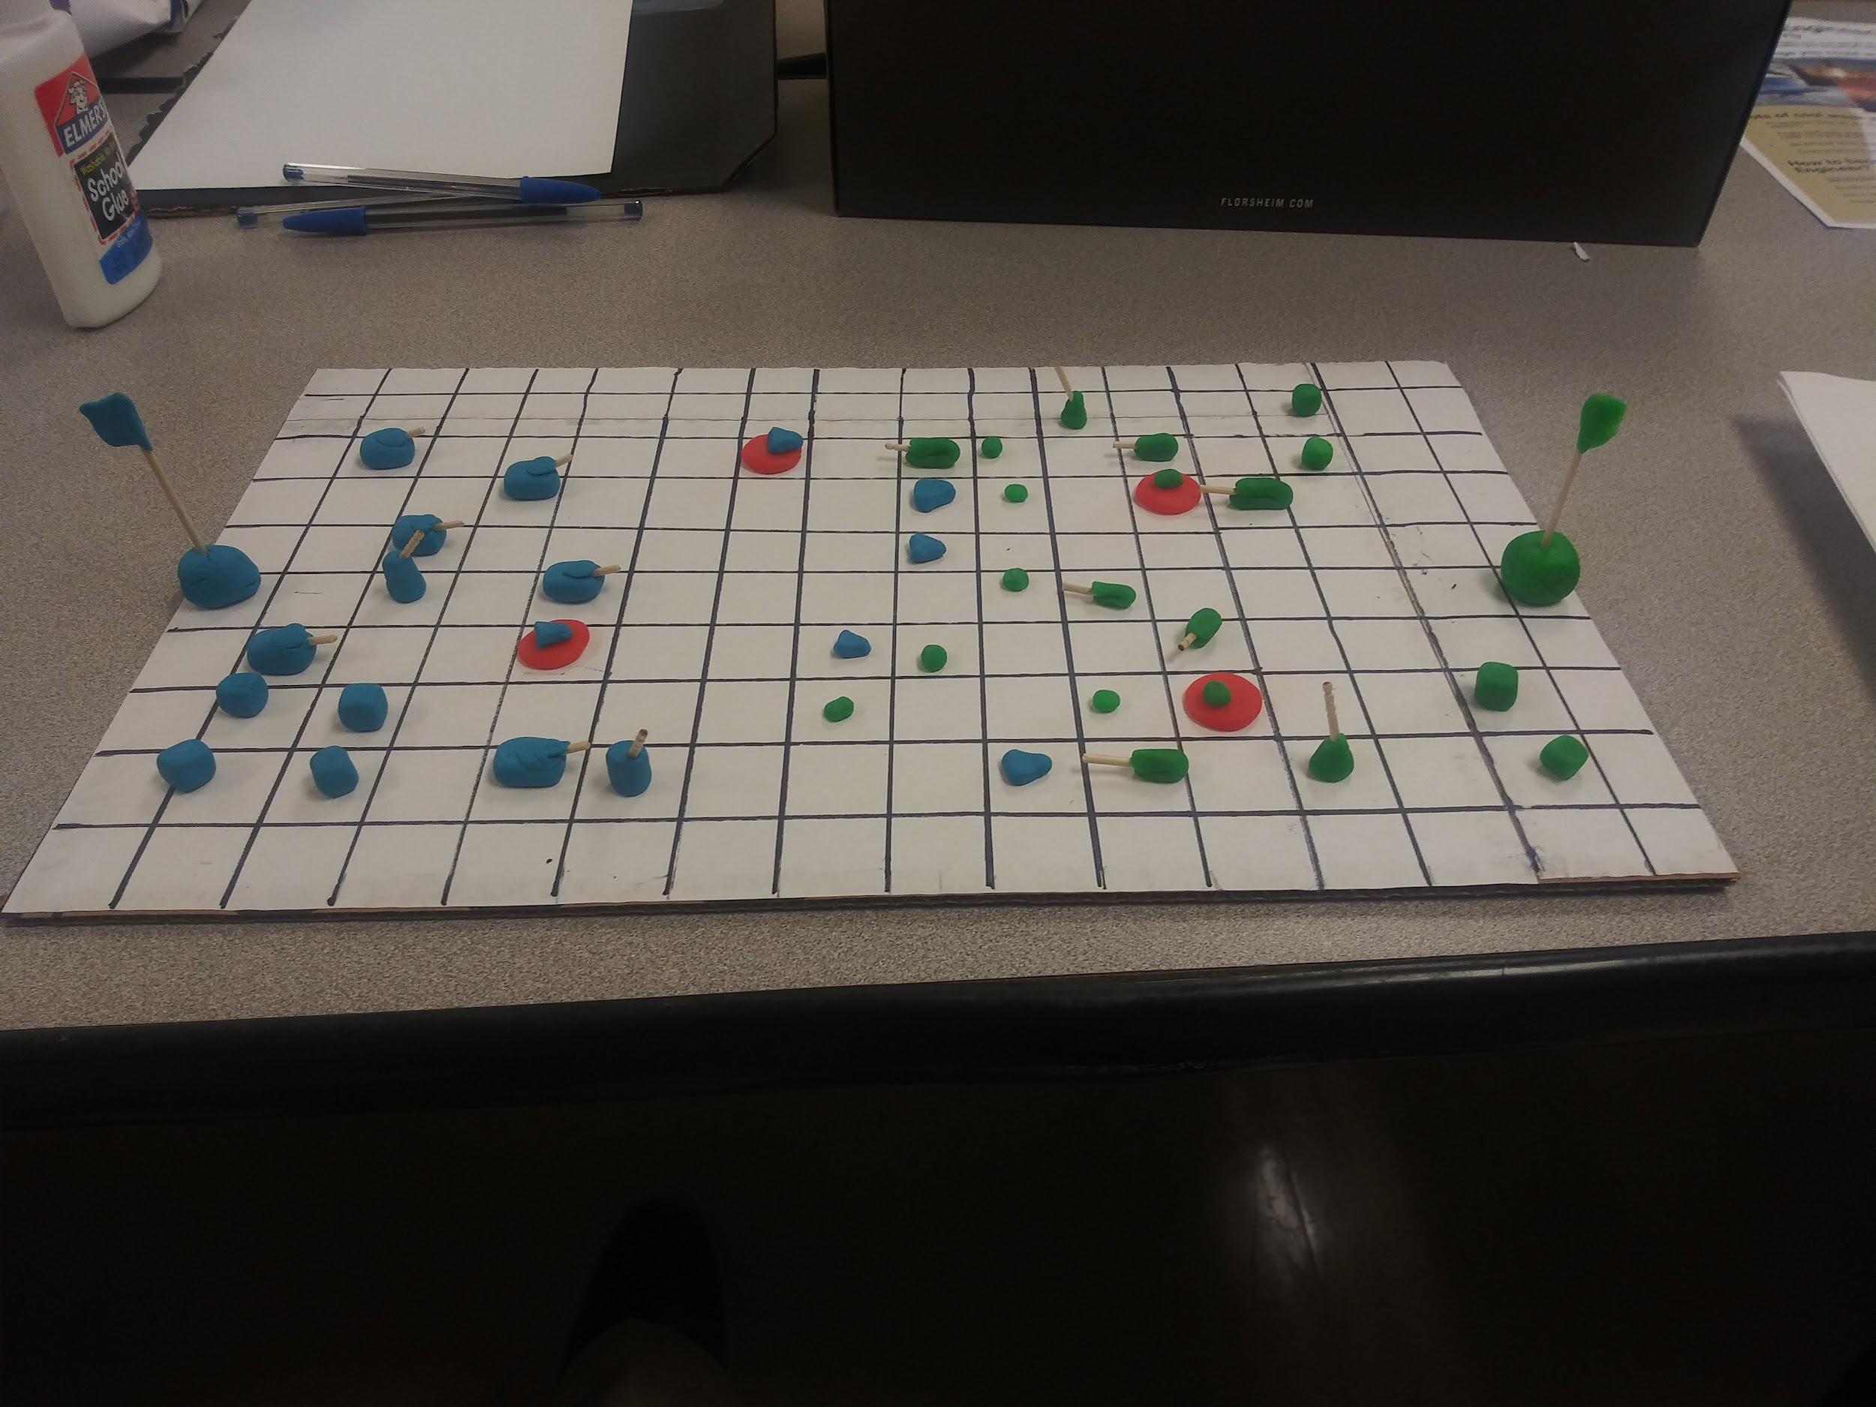

Ages: 10+

Tac-Tile warfare is a turned based strategy game taking place on a 16x8 battlefield. The goal of the game is to capture or destroy all of the enemy bases on the field.

The types of game pieces that you will play with are buildings, units, and capture points.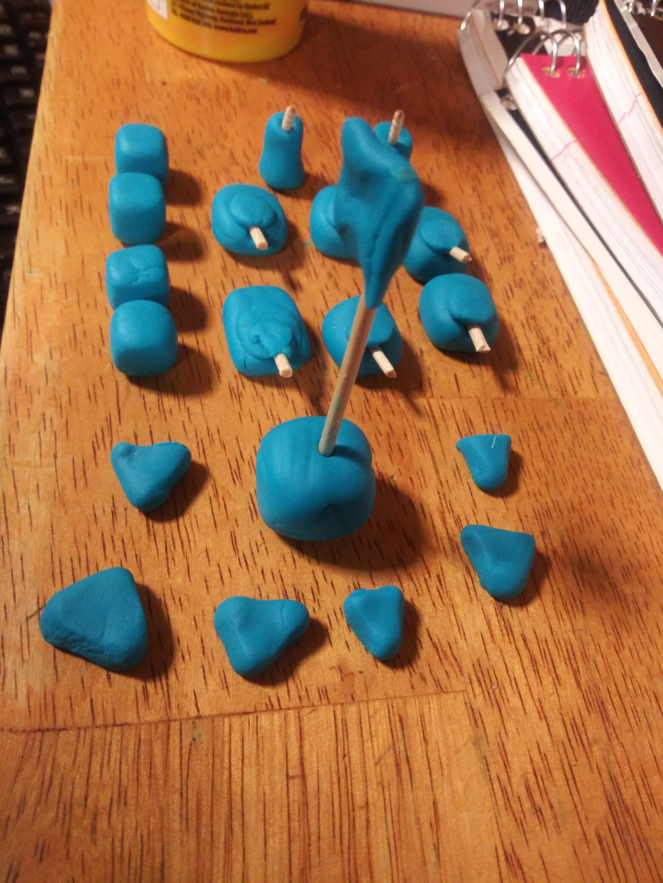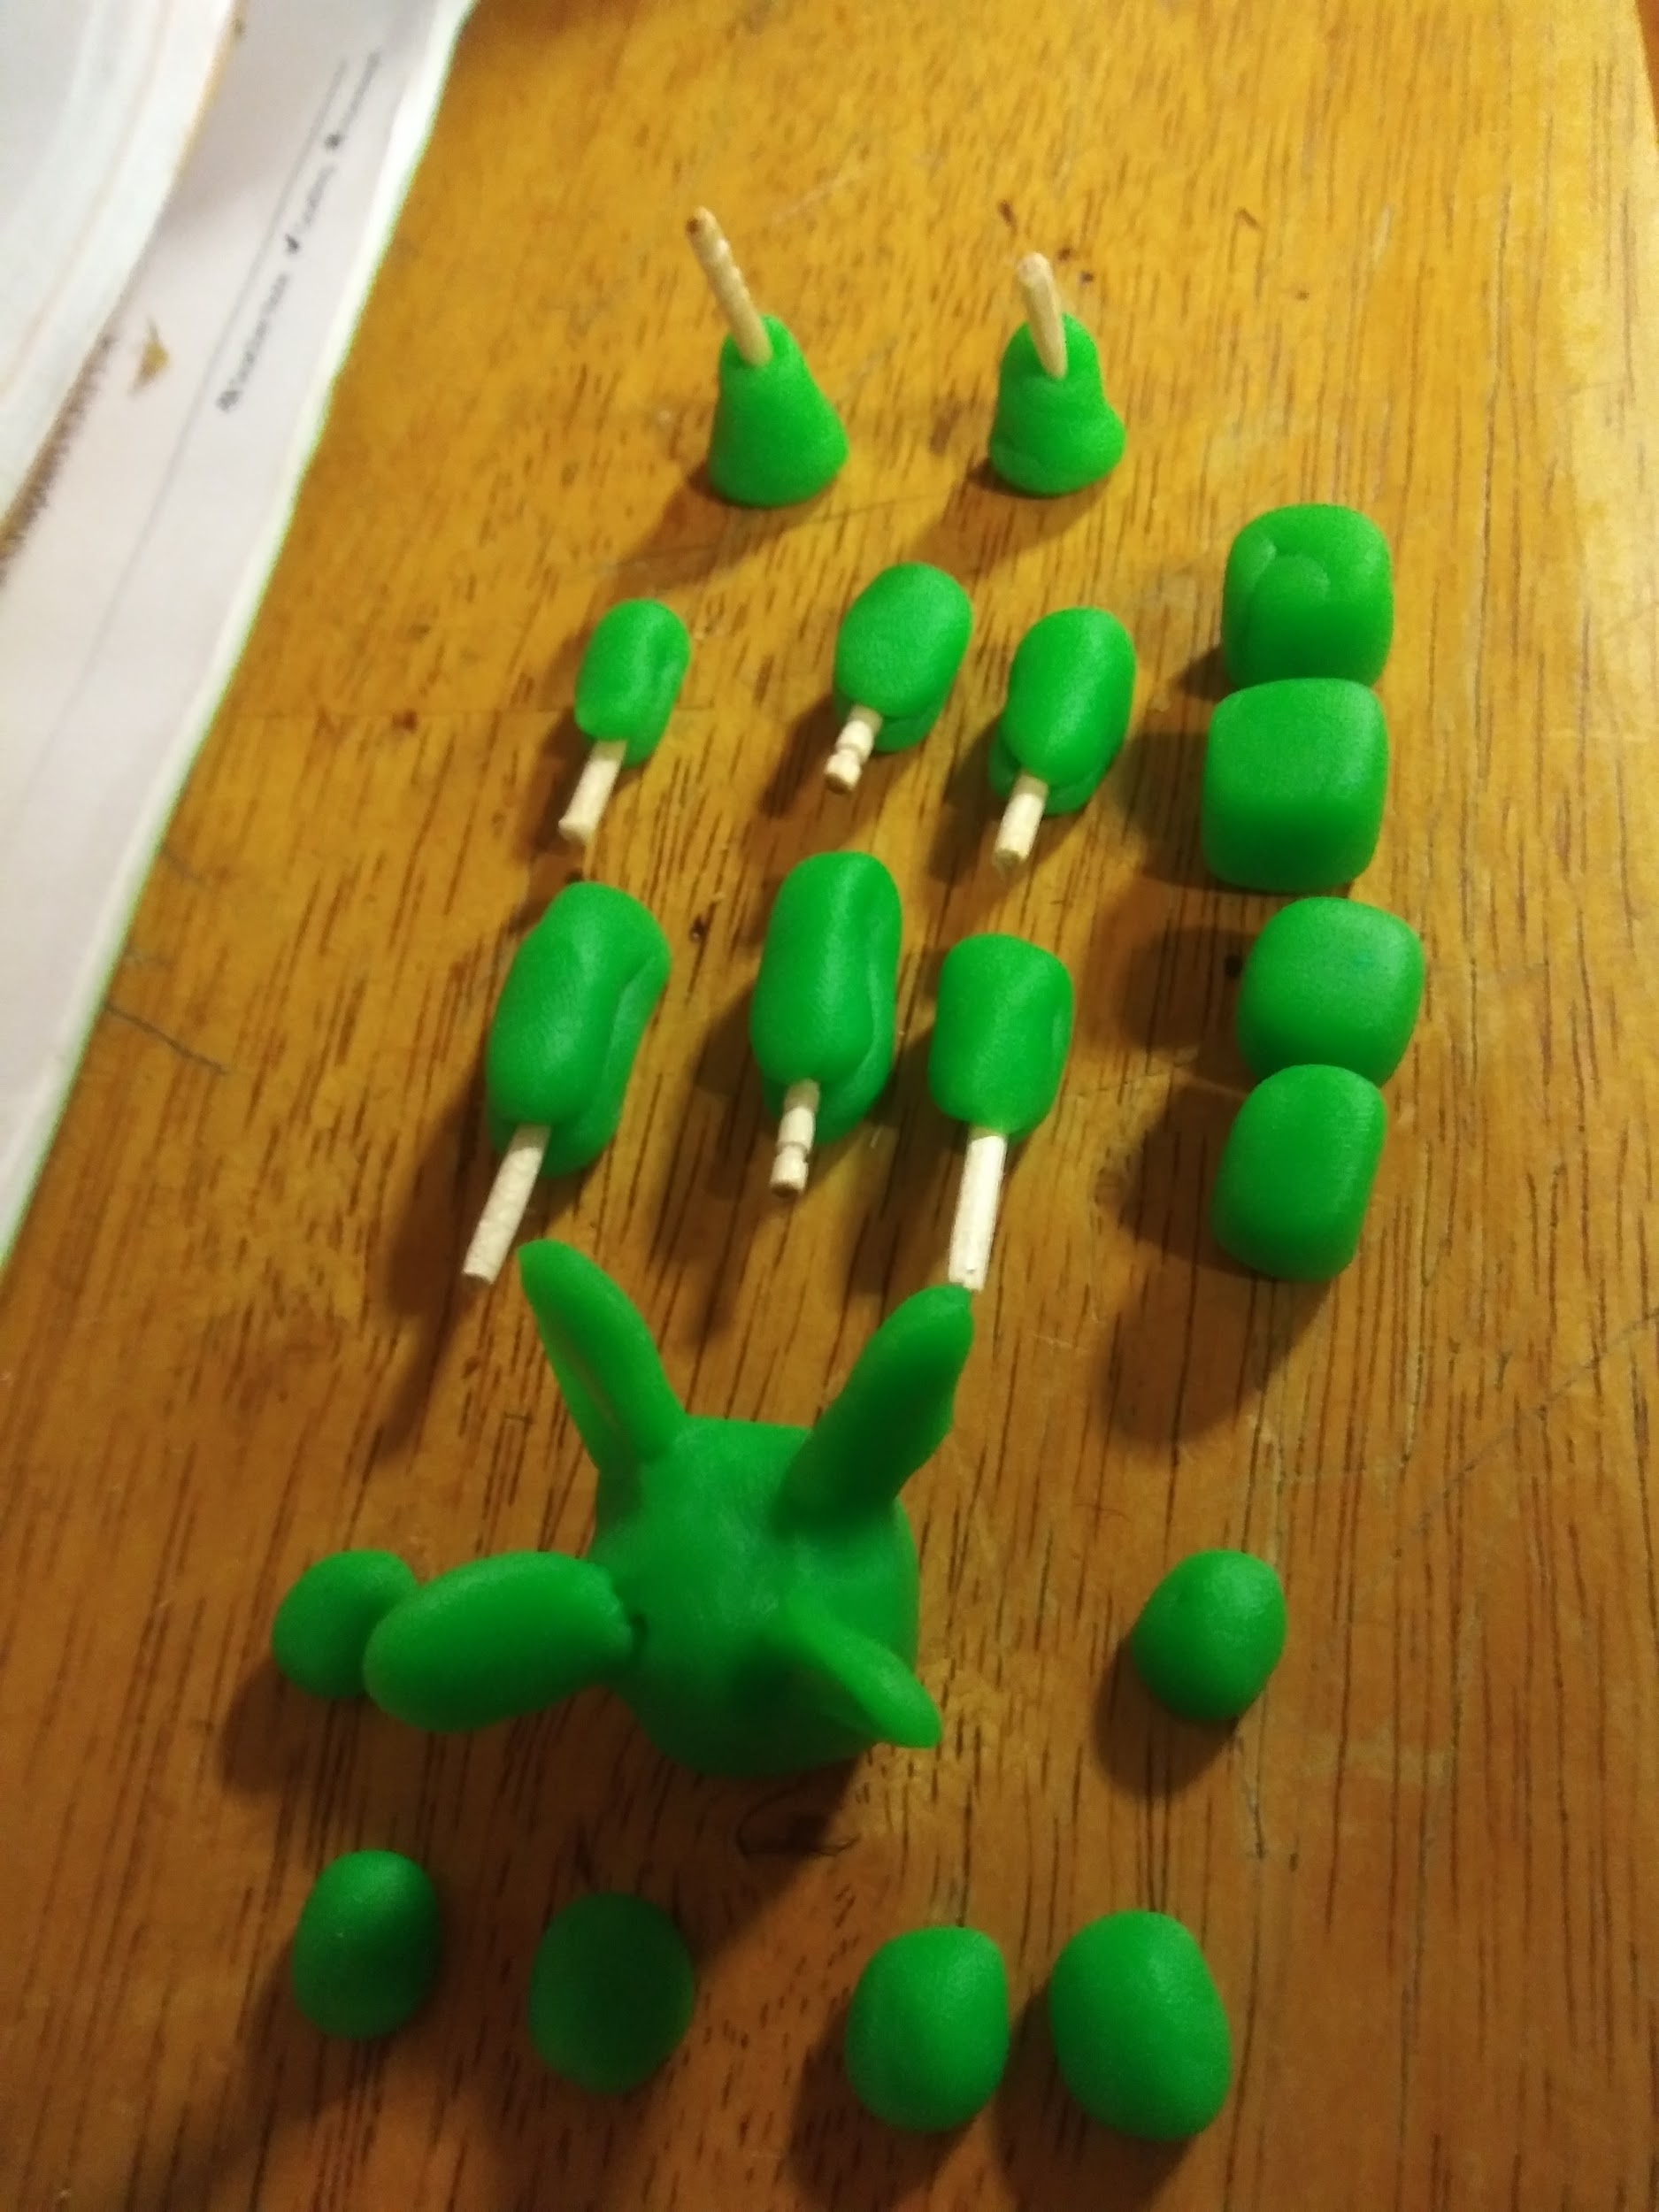

Capture points are a source of income to continue expanding your base and army. Holding one gives you 1 point per turn. To occupy one place and keep a unit there. During the forst round these will be randomly set near and away from your HQ piece

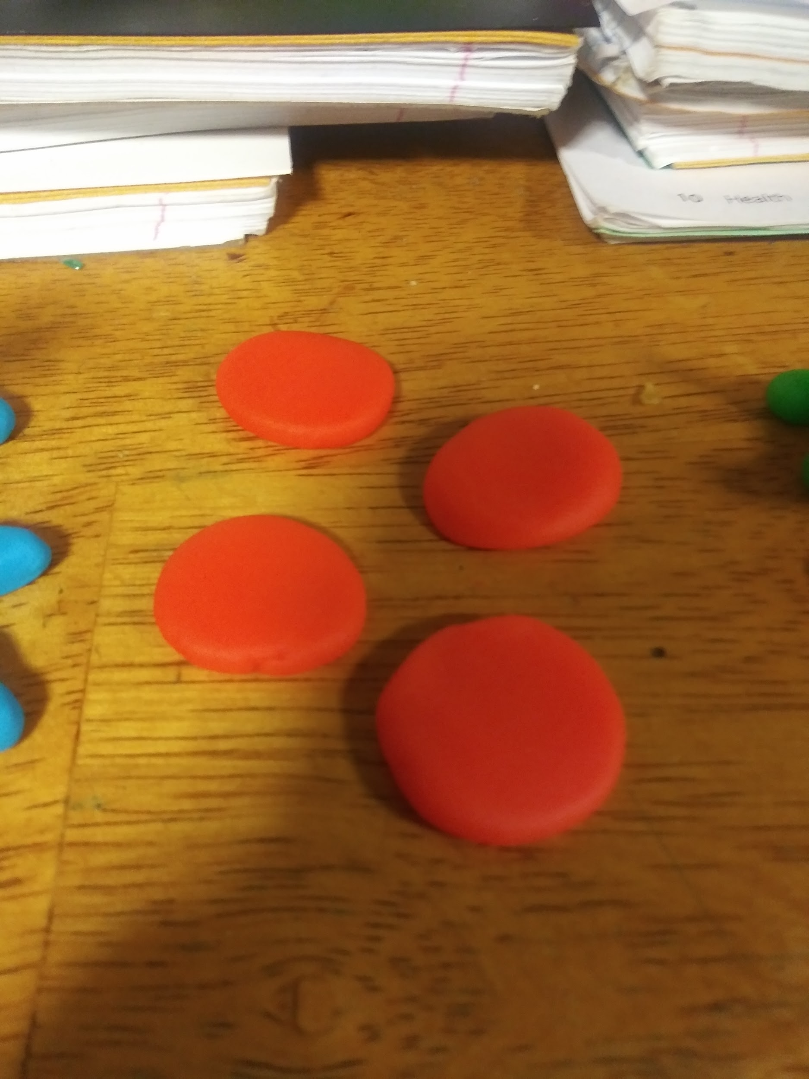

Units are offencive pieces used to destroy units, and buildings. Soldiers can capture buildings.

Buildings in this game are important for controlling your army and making defenses. Losing or taking buildings in the game can change the game drastically. You cannot build within a 2 tile radius away from allied pieces

HQ is the most important piece if it is destroyed or captured you lose. Units can be deployed from here. You cannot build more than one HQ.

Camps are buildings that increase the amount of units that you can control, when a encampment is destroyed and your upkeep is full you cannot build any more units. Units can be deployed from here. Costs 1 point creates 4 upkeep

Artillery is a offensive building used in destroying enemy units and buildings within its range of 4 tiles every 2 turns. Cannot move when placed. Can be captured by soldiers. Costs 8 points

Soldiers are light units that can move 1 tile or attack a unit in a 1 tile radius per turn. It takes 2 turns to capture a building, to capture a building put the soldier on the same tile with the building. Costs 2 points and 1 upkeep to control.

Tanks are heavy units but cannot be destroyed by soldiers. It can move 1 tile or attack in a 2 tile radius per turn. Costs 4 points and 2 upkeep to control.

When you first start the game you start with 1 HQ, soldier, and camp.

Winning conditions are:

enemy HQ captured/destroyed or when you hold all capture points

